Conservation Corner Article for March 23, 2021
Article 284_Farms are Greener than John Deere Green_3/23/2021
Or
Renewable Energy from Farms
Jodi DeHate, Missaukee MAEAP Technician

Renewable energy from agriculture isn’t anything new. It is the fastest growing energy source in the United States, to the tune of a 100% increase in usage from 2000 to 2018. What are these energy sources? There are three main sources for renewable energy coming from farms or farmland: wind, solar, and biomass. Biomass can mean quite a few different things. It can mean ethanol, biodiesel, methane production, or even compost to use on fields and gardens.
Windmills, not the Don Quixote type
Windmills in some form have been used for a long time. Usually for pumping water or grinding grain for flour. Today’s windmills create energy for electrical cooperatives. To the tune of 6.6% of all energy comes from wind production. The Stoney Corner Wind Farm, West of McBain has 29 windmills that create enough energy annually for 13,000 households. This would power all the households in Wexford County and the city of Cadillac with energy to spare.
Any of these new energy sources create infrastructure, jobs, and tax revenue for both townships and counties. Heritage Energy, the company that owns the windmill farm, has been a really good partner for the McBain areas schools and provides donations for projects that benefit kids.
Solar Energy- not just for crops
Farms already harness solar energy by growing crops, yet solar panel farms are starting to pop up in the area. There’s one on M-55 across from Wolverine Power and another behind Bader & Sons on M-55/M-66 north of the M-55 interchange. Solar and wind energy is expected to create the bulk of gains in renewable energy sources. Right now 21% of US energy is created by wind and solar. By 2050 that’s supposed to increase to 42%.
While solar panels take up quite a bit more space on the landscape, they can be beneficial beyond the energy production. Many solar farms plant pollinator habitats between the panels as well as native grasses and flowers. Small ruminants like sheep and goats can graze between the panels. The panels provide some shade and the animals take off plant matter so the area wouldn’t need to be mowed mechanically.
Technology is a lot better than even 10 years ago, making solar panels more efficient on cloudier days and a lot lighter than older panels. Making it easier and more cost effective to install for home or farm use.
Biomass- ethanol, biodiesel, methane digestion
Ethanol and Biodiesel are different but similar. Both are used in fuel for vehicles. Gas vehicles can handle up to 10-15% ethanol blended into gas without any problem. Biodiesel is also blended with petroleum-based diesel and can be used in most diesel vehicles.
If you’ve ever watched an episode of Moonshiners, you know how to make ethanol. Ethanol is an alcohol made from corn, barley, sugarcane, or really any grain. Cellulosic ethanol is made from woody pulp like corn stalks or switchgrass and that’s a bit of different process. Ethanol production has been a huge benefit to many cash crop farms since they grow the materials needed to make the product. By-products from ethanol production such as the dried distiller’s grains (the dried mash from the ethanol making) is a great feed for livestock. A lot of dried distiller’s grain is used on our dairy farms.
Biodiesel is made from fat, either vegetable or animal fat. Most biodiesel is made using soybean or canola oil. Canola meal and Soybean meal make excellent feed for livestock. Glycerin is another by-product and has thousands of uses. Both fuels provide a revenue for crops to be used and farmers to market their crops.
Methane Digestion is probably the least known type of energy production. It’s been around for decades, but not widely used here in the US. In fact, there are only 6 digesters in Michigan, but that could change in the next few years. Methane digesters take animal manure and harvest the methane from it to convert to a type of gas, not unlike natural gas. As you can imagine, Missaukee County with the large amount of dairy farms could be home to a methane digester or two.
California has created renewable energy standards to meet and is buying up credits for renewable energy. Those standards are creating a favorable market for farms to at least look into investigating on-farm methane digesters.
The digesters take the manure and, in some places food waste, and places the materials in a sealed container called a reactor. The reactors contain microbial communities that break down the waste and produces biogas and digestate. Digestate, in short, is water and the fiber from the original materials.
The biogas is either used on farm in generators or converted, and put into a receptive natural gas line to be sold to an energy cooperative. It’s way more complicated than that, but that’s the gist of things.
The water and solids aren’t wasted from the digestate either. Very few nutrients are lost in the process. When farmers land apply the solids to their fields they still get a natural fertilizer with a lot less odor. The waste water could be used for irrigation purposes during the growing season, or if filtered enough, could be discharged back into the ground.
All the things
While renewable energy is a great way to reduce dependence on petroleum, it cannot be the only type of energy we rely on. All of these systems can fail and aren’t quite as reliable as petroleum yet. There’s definitely promise and potential in renewables.
For farmers and landowners, if you have wind and solar already on the farm or are looking into a solar farm please make sure you take a look at the Farmland Preservation page or contact the PA116 office to make sure you can keep your designation with PA116. The Natural Resource Conservation Service (NRCS) and USDA offer some incentives for doing energy audits on the farm and then installing more energy efficient equipment. The same program, Rural Energy for America Program (REAP) offers grants and loans for some large projects like methane digesters.
Above all, please look at any contracts for methane digesters with the same scrutiny as the windmill contracts from a decade ago or the natural gas wells from the 70’s.

Jodi DeHate is the MAEAP technician covering Missaukee, Wexford, Kalkaska, and Crawford counties. She can be reached at jodi.dehate@macd.org or 231.839.7193 at the Missaukee Conservation District.

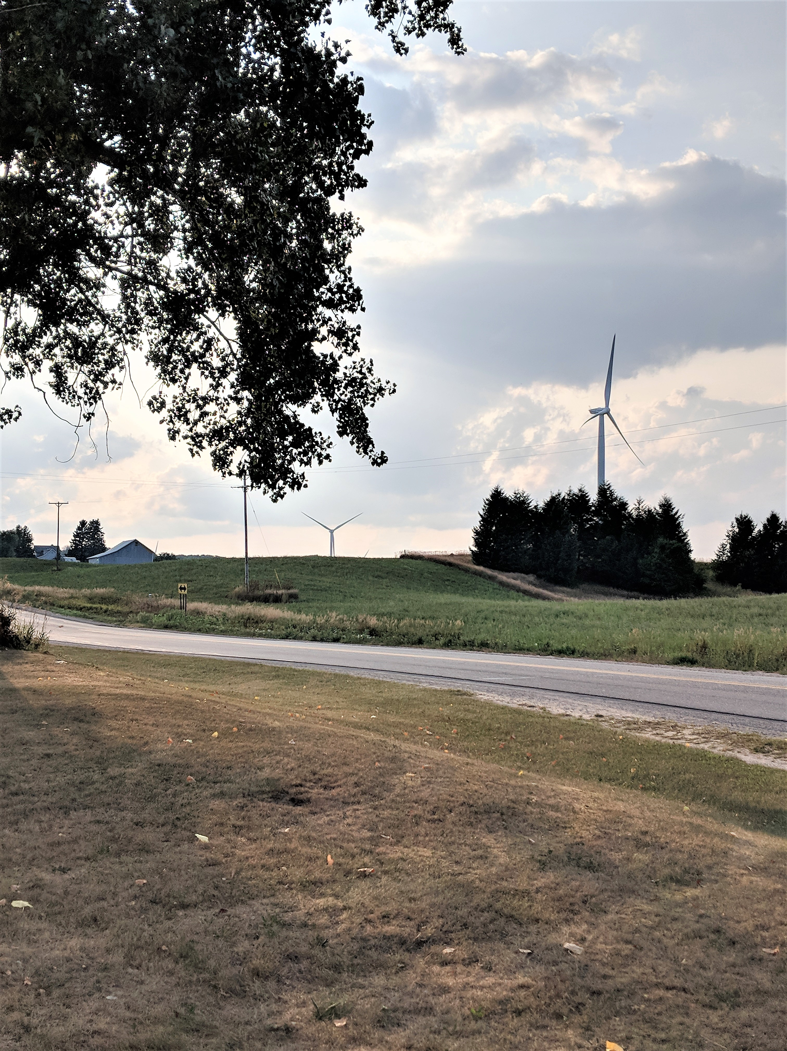
284-A
Windmills West of McBain.
Photo Credit Jodi DeHate

284-C
Methane Digester at MSU
Photo Credit: MSU
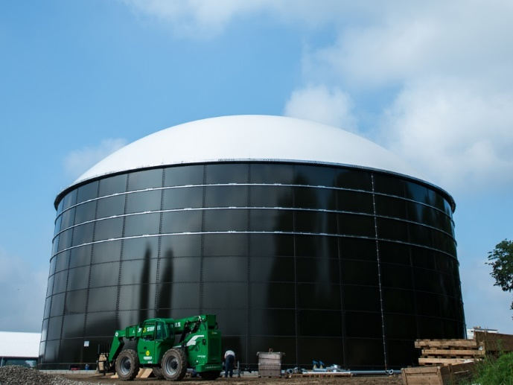
284-B
New solar panels
Photo Credit, Michelle Hill
